Final project Self-assessment report
Team: <StudentID1>-<StudentID2>-<StudentID3>
GitHub repo URL:

TEAM INFORMATION
Student ID | Full name | Git account | Contribution | Contribution percentage (100% total) | Expected total points | Final total points
<StudentID1> | <Student 1 fullname> |  | <List of tasks done by student 1>
<StudentID2> | <Student 2 fullname> |  | <List of tasks done by student 2>
<StudentID3> | <Student 3 fullname> |  | <List of tasks done by student 3>

FEATURE LIST
Students must input minus points to every uncompleted feature in the SE column.
*SE: Self-evaluation
*TR: Teacher review
ID | Features | Grade |  |  | Notes
 |  | Point | SE* | TR*
1 | Overall requirements
 | Database design | -1
 | Database mock data | -1
 | Website layout | -2 |  |  | At least two layouts for customer and admin websites
 | Website architect | -3 |  |  | Based on MVC. With a clear separation of concerns.  Client-side validation, Input validation, Business rule validation, …
 | Website stability and compatibility | -2
 | Document | -1
 | Demo video | -5
 | Publish to public hosts | -1
 | Development progress is recorded in Github | -7
2 | Guest features
 | Home page | -0.25 |  |  | Layout and content of the home page
 | View list of products | -0.25
 | Filter products by |  |  |  | A combination of the criteria
 | - Product name | -0.25
 | - Category, manufacturer | -0.25
 | - Price range | -0.25
 | Sort product by price, creation time, ... | -0.25
 | Product paging | -0.25
 | AJAX product paging | -0.25
 | SSR search, filtering, and paging | -0.5 |  |  | Update the browser URL on handling AJAX.  View source on the browser should have the product list in HTML
 | View product details | -0.25
 | - Show related products | -0.25
 | - View list of product reviews | -0.25
 | - Add a new product review | -0.25 |  |  | Only logged-in users can add reviews
 | - AJAX paging product review | -0.25
 | Shopping cart
 | - Add a product to the Cart | -0.25
 | - View products in the Cart | -0.25
 | - AJAX update the product count in the Cart | -0.25 |  |  | Must update the corresponding cart prices
3 | Authentication and authorization
 | Use a popular authentication library | -1 |  |  | Passport
 | Registration | -0.25
 | - Verify user input: password complexity, full name, ... | -0.25
 | - AJAX checking username/email availability | -0.25
 | - Account activation by email | -0.25
 | Social Sign-up/Sign-In | -0.25 |  |  | Google or Facebook
 | Login to the website | -0.25
 | Authorize website features | -0.25
 | Forgot password by email | -0.25
4 | Feature for logged-in users
 | Update user profile | -0.25
 | - Verify user input | -0.25
 | - Update the user's avatar | -0.25
 | - Update password | -0.25 |  |  | The user must input old password to update new password
 | Checkout and payment
 | - Bind the shopping cart to the user when login | -0.25
 | - Input shipping details | -0.25
 | - Process payment | -0.25
 | - View order list and status | -0.25
 | - View order details | -0.25
5 | Administration features
 | Update your admin profile | -0.25
 | View account list | -0.25 |  |  | account: customer, admin
 | - Filter account by name, email | -0.25
 | - Sort account by name, email, registration time, ... | -0.25
 | - AJAX paging account list | -0.25
 | View account details | -0.25
 | Ban/unban an account | -0.25 |  |  | Cannot ban your own account
 | Manage product categories, manufacturer | -0.25
 | View product list | -0.25
 | - Filter product by name, category, manufacturer | -0.25
 | - Sort product by creation time, price, total purchase | -0.25
 | - AJAX paging product list | -0.25
 | Create a new product | -0.25
 | - Upload multiple product photos | -0.5
 | - Add product to a specific category, manufacturer, ... | -0.25
 | - Specify product status | -0.25 |  |  | On stock, Out of stock, suspend, ...
 | - Verify user input | -0.25
 | Update a product | -0.25
 | - Add, and remove product photos | -0.25
 | - Change product category, manufacturer, ... | -0.25
 | - Update product status | -0.25 |  |  | On stock, Out of stock, suspend, ...
 | - Verify user input | -0.25
 | Customer's orders
 | - View list of orders sorted by order creation time | -0.25
 | - Filter order by status | -0.25
 | - View order details | -0.25
 | - Update order status | -0.25
 | Reports
 | - View revenue report in time range: day, week, month, ... | -0.25
 | - View top revenue by product in time range: day, week, month | -0.25
6 | Advanced features
 | Payment system integration | 1 |  |  | Integrate sandbox system of Momo, VNPay, PayPal, Stripe …
 | Use a search engine library | 0.5 |  |  | Elasticsearch, Angolia, …
 | Use memory cache to boost website performance | 0.25 |  |  | Redis, Memcache
 | Analyze and track user actions | 0.25 |  |  | Google Analytics, Google Tag Manager, Microsoft Clarity
 | Show interactive chart in reports | 0.25
 | Dockerize your project | 0.5
 | CI/CD | 0.5 |  |  | Github Actions
 | List all other advanced features that your team has done...

GIT HISTORY

Contributors
Screenshot contribution graph of your team in Github
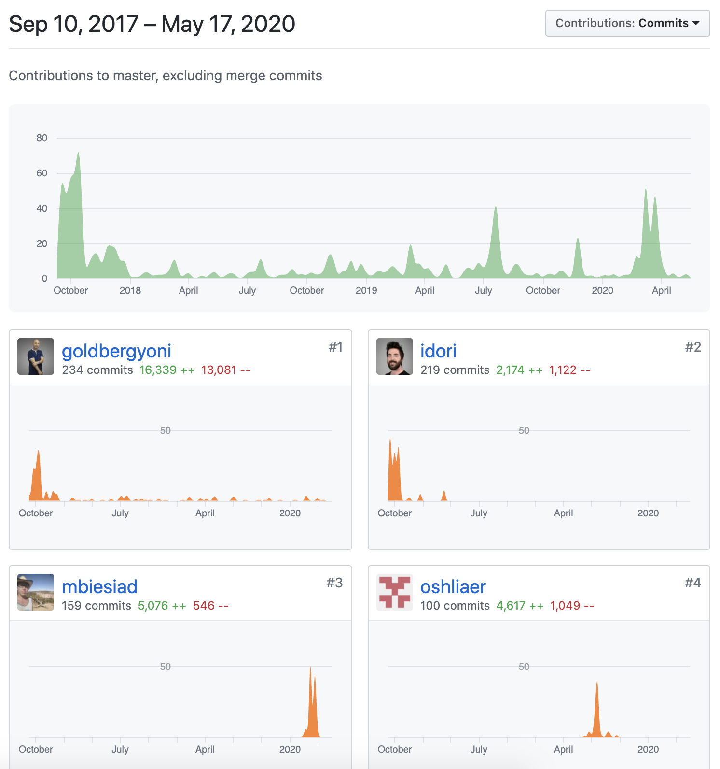

Commits
Screenshot commits of your project
